5th Annual
Port Sydney Firefighters Association
CHARITY GOLF TOURNAMENT

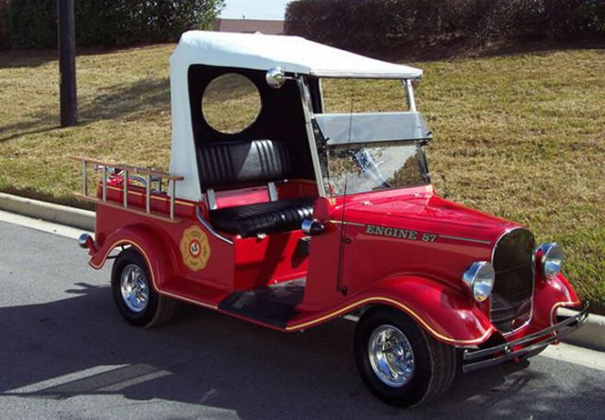
Wednesday 27th, September 2017
Grandview Golf Course, Huntsville

11:00 AM Shotgun Start
$150/golfer or $600/foursome includes:
Continental Brunch, BBQ dinner and prizes.

All proceeds will benefit the Port Sydney Firefighters Association

TOURNAMENT ENTRY FORM:

Contact:

Company:

Address:

City/PC:

Tel: Email:

Names for Foursome:

First Name | Last Name | Company

I am playing alone, please place me in a foursome.

Please make cheques payable to Port Sydney Firefighters Association.
Payment must accompany registration. DEADLINE FOR ENTRY – Sept 15, 2017
THANK YOU FOR YOUR SUPPORT!

Event Contacts: D’Arcy LeClaire 705-783 1626 darcy@avenel.ca

